MART Elections 2015 Candidate Bios and Statement of Purpose
Chair
Dr. Jim Ginther is an Archival Team Leader and Senior Archivist for the Archives Branch, History Division, United States Marine Corps. His educational credentials include a Ph.D. in Military History from Texas Tech University (1999), an MA in History from Abilene Christian University (1993), and BS in Business Administration from the University of Missouri-St. Louis (1990) and most recently and MDIV from the Samuel DeWitt Proctor School of Theology at Virginia Union University, where he was class valedictorian (2015).

He began his career as an graduate student assistant and later as an archivist for the Vietnam Archive at Texas Tech University. He also served as an archivist for the university’s Southwest Collection before coming the Marine Corps in 2000 as its Personal Papers Collection Curator. Jim has been involved with the SAA's Military Archive's Round Table since its humble origins at a meeting of like-minded professionals in a park on the Chicago River in 2011. He has made numerous presentations before the Society of American Archivists on such issues as implementation of the Archives HP Trim ERM software, the challenges of description and management of archival records in electronic systems, and the challenges of collecting historical documentation on military operations in the electronic age. He has served as the Vice Chair of the Military Archives Round Table for the past three years, has worked with its chairman to coordinate events at the annual SAA meeting, get MART presentations onto the program, and was one of the original drafters of the MART By-Laws.

He sees the way ahead for MART in encouraging more cooperation and information sharing within the military archival community not only within DOD but across the board to other institutions which may hold military records but not define themselves as military archives. Over the next couple of years he would like to see MART revisit its by-law objectives and work toward concrete solutions to the issues addressed, work toward opening up greater cooperation between the MART and other sub-groups within the SAA.

Vice Chair
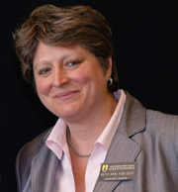
Beth Ann Koelsch has been the curator of the Betty H. Carter Women Veterans Historical Project (WVHP) at the University of North Carolina at Greensboro since 2008. The WVHP collects oral histories and other materials that document the contributions of women in the U.S. military and the American Red Cross (http://libcdm1.uncg.edu/cdm/landingpage/collection/WVHP/). Koelsch previously worked as a project archivist at the Sallie Bingham Center for Women’s History and Culture at Duke University, Durham, NC. She received her Masters in Library Science (MSLS) degree from the School of Information and Library Science at the University of North Carolina at Chapel Hill in 2007 and earned her undergraduate degree from Duke University in 1990.

Statement of Purpose:
MART is made up of different types of repositories such as federal, state, military, academic, museums, and non-profits. Because our repositories operate under an array of guidelines, strictures, and availability of resources, MART members need to be creative in cooperative efforts.
My first goal for MART is to have MART members list their knowledge specialties, describe the collections they work with, and the accessibility of the materials in those collections. This will enable members to have contacts with whom they can consult with and also refer researchers.
I am also interested in establishing working groups to take on projects such as:
- Creating a resource list/clearing house of repositories with significant military collections and create a publicly available resource page with this information;
- Establishing a set of consistent terms/thesaurus to enable search engines to search multiple databases simultaneously with a single query; and
- Discussing a social media presence to raise the visibility of our collections.
Vice Chair
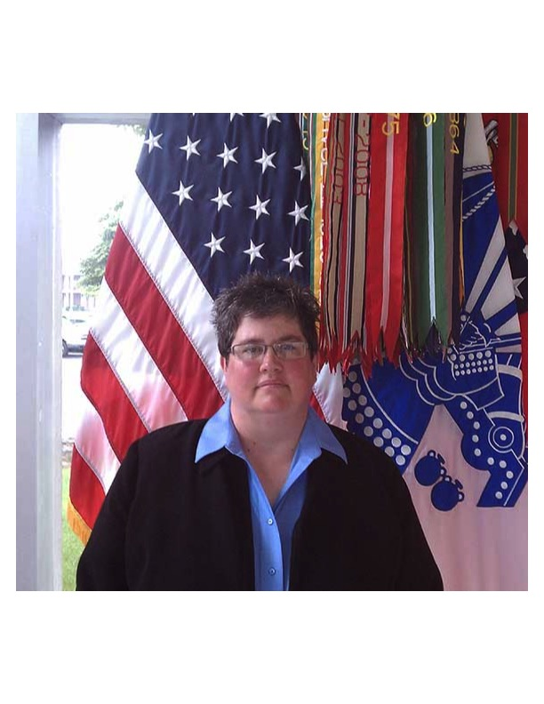
Melissa Wiford is currently the Chief of the Archives Branch, United States Army Military History Institute (USAMHI), United States Army Heritage and Education Center (USAHEC), United States Army War College, Carlisle Barracks, PA.

Wiford began working in the archival profession twenty-one years ago after serving in the United States Army for nine years with overseas tours in Korea and in Operation Desert Shield/Desert Storm, where she served with the 101st Airborne Division. Wiford previously worked at the Ohio Historical Society (OHS) in the Reference Services Division, Manuscript Divisions, and on the Archives, Library, and Museum Access (ALMA) Team. She also worked in the State Archives of Ohio where she worked with the Ohio Adjutant General’s Civil War records as well as other military records.

During her time at OHS, she worked extensively with the organization’s digitization initiatives to include the creation and development of The African American Experience in Ohio: 1850-1920; Fight for the Colors: Ohio’s Battle Flags; and OhioPIX: Online Picture Gallery. Wiford also served as a consultant to the Borden Foods, Inc. Archives. She has been employed at the USAMHI/USAHEC for eleven years, originally in the Patron Services Division before moving to the Archives Branch.

I see the MART expanding to the next level of recognition by SAA, extending our knowledge to fellow Archivists around the country, developing our current methods of communication to further deliver our statement of purpose and capabilities. We have unlimited potential to reach out to those archivists who previously felt isolated in their craft, building our own networking system to provide information to all who need it. We can provide online training and seminars to an extent that only a few years ago was unthinkable. Leadership is vital to this process, and that is why I chose to run for office.

Secretary

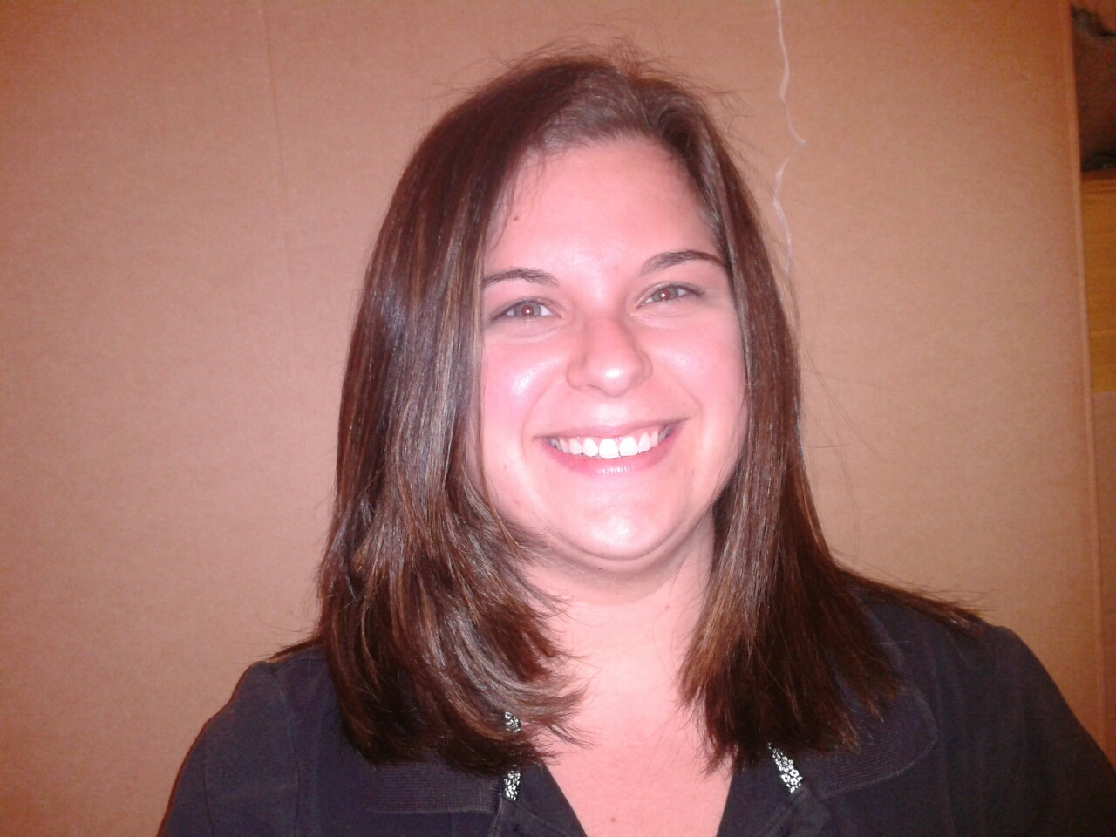

Laura Jowdy
I’ve been the Archivist at the Congressional Medal of Honor Society for over seven years. Since I started, I’ve developed and implemented the entire archival program. Since I work alone, I’m responsible for all aspects of the Archives and Library, from accessioning to folder-labeling to environmental monitoring and disaster management (with reference-desk duties thrown in for fun!). I served as the Newsletter Editor, a board position, for the South Carolina Archival Association for two years. I earned a MLIS in 2006 from the University of South Carolina, following a B.A. in History from Hiram College (Hiram, OH) in 2004. I became a Certified Archivist in 2007.
A founding member of MART and a member of the Society of American Archivists since 2004, I’m looking to ‘get my feet wet’ in an official SAA setting as the Secretary for MART. As someone who works alone without the benefit of a large research library or staff, I believe whole-heartedly in this group. It has kept me from feeling so alone and the potential for this roundtable to help other archivists is great – we can do so much more! As Secretary, I will embrace the need to increase our standing and visibility within SAA.

Secretary

Amy Mondt, CA, is the Associate Director of the Vietnam Center and Archive at Texas Tech University. In 2008 she began her time at the VNCA as the reference archivist, helping patrons with their research, working on outreach programs, and creating exhibits. In 2012 she became the collection development archivist and had the privilege of working with the archive’s donors, mostly Vietnam veterans. Amy is now the Associate Director of the archive, where she works with the other archivists on her team to help preserve the record of the Vietnam War.
Amy graduated from Texas Tech University with a Bachelor of Arts degree in Anthropology in 1997 and a Master of Arts degree in Museum Science in 2000. She became a Certified Archivist in 2007. Before joining the VNCA, Amy was the Director of Collections and Archives at the Petroleum Museum in Midland, Texas
MART is a great place to bring military archives and their archivists closer together. A place where members speak the same language and understand the unique needs of military collections. Members range from those who work in a lone arranger shop to those who work in a large institution. MART is the place where they can go to commiserate, find answers to questions, and connect donors to the appropriate facility. I would like to see this camaraderie continue to grow and for MART to develop something more formal, like professional development workshops, or guides for other archives to help them celebrate important holidays like Veterans Day. MART’s membership may be small, but it is a passionate group of people who truly want to help others understand military collections. I envision MART marketing its values to increase awareness within the rest of the profession. This will position the group to fulfill its mission and be of service to those who need help with their military materials.

